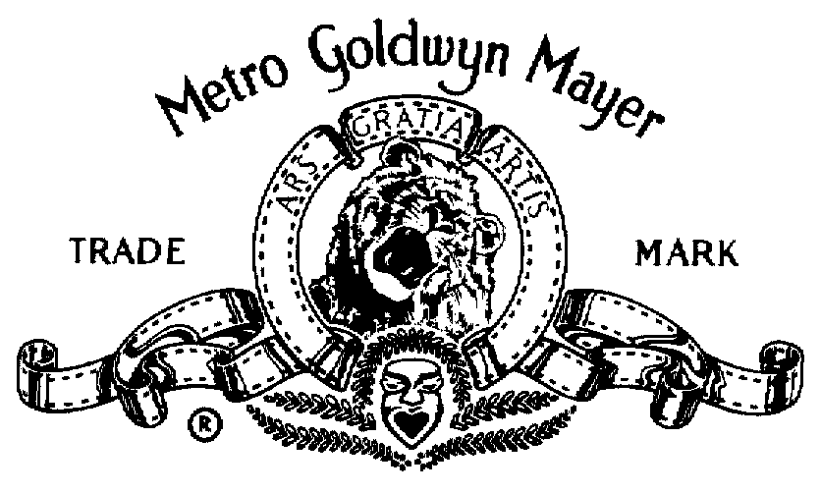

METRO-GOLDWYN-MAYER PICTURES presents

a SPLENDID PICTURES MAVERICK FILMS DYLAN SELLERS production

FRANKIE MUNIZ

HILARY DUFF



ANGIE HARMON

KEITH DAVID | CYNTHIA STEVENSON | ARNOLD VOSLOO

IAN McSHANE | DANIEL ROEBUCK | DARRELL HAMMOND

Casting by  JOHN PAPSIDERA CSA | Music by  JOHN POWELL | Music Supervisor  JULIANNE JORDAN | Costumes Designed by  SUZANNE McCABE

Edited by  JIM MILLER | Production Designer  RUSTY SMITH | Director of Photography  DENIS CROSSAN, BSC

Associate Producers  VESLEMOEY RUUD ZWART  TOM GULBRANDSEN | Co-Producer  ROBERT MEYER BURNETT

Executive Producers
MARK MORGAN | JASON ALEXANDER | JENNIFER BIRCHFIELD-EICK | KERRY DAVID
DANNY GOLD | MICHAEL JACKMAN |  | BOB YARI

Produced by  DAVID C. GLASSER ANDREAS KLEIN GUY OSEARY | Produced by  DYLAN SELLERS DAVID NICKSAY

Story by
JEFFREY JURGENSEN

Screenplay by
ASHLEY EDWARD MILLER & ZACK STENTZ
and SCOTT ALEXANDER & LARRY KARASZEWSKI

Directed by
HARALD ZWART
Unit Production Manager George Chapman
First Assistant Director Jim Brebner
Second Assistant Director Andrew M. Robinson

Unit Production Manager David Nicksay

CAST
Cody Banks Frankie Muniz
Natalie Connors Hilary Duff
Ronica Miles Angie Harmon
CIA Director Keith David
Mrs. Banks Cynthia Stevenson
Molay Arnold Vosloo
Mr. Banks Daniel Roebuck
Brinkman Ian McShane
Earl Darrell Hammond
Dr. Connors Martin Donovan
Surveillance Van Agents Marc Shelton)
Chris Gauthier
Double Agent Harry Van Gorkum
Alex Banks Connor Widdows
Mom Eliza Norbury
Baby Justin Kalvari
Saul Kalvari
CIA Assistant Andy Thompson
Paranoid Agent Andrew Johnston
McAllister Benjamin Ratner
Army Colonel Stephen E. Miller
Cynical Agent Miriam Smith
Amy Alexandra Purvis
Jefferson Buddies Chad Krowchuk
Jeffrey Ballard
Shayn Solberg
Anthony Quao
Helicopter Agent Dee Jay Jackson
Rosychuk Peter New
Earl's Intern Jared Van Snellenberg
Young Girl Natalie Sellers
Fenster Noel Fisher
Fenster Droogs Andrew Francis
Branden Nadon
Natalie's Friends Jessica Harmon
Hayley Bouey
Mr. Yip Chang Tseng
Bug Man Michael Cromien
Disgruntled Agent Dan Zukovic
Inept Agent Fiona Hogan
Kitchen Cleaning Agent Eric Keenleyside
Bedroom Agent Scott Swanson
Dog Walker Terence Kelly
Gardener Gary Peterman
Farting Agent Dennis Caughlan
Animal Behavior Scientist Xantha Radley
Rapper Prevail
Intelligence Agent Alex Diakun
Relationship Agent Lisa Calder
Dark Agent Alan C. Peterson
Hologram Babe Moneca Delain
School Nurse Sonja Bakker
Security Guard Ty Olsson
Croupier Forbes Angus
Waitress Lorena Gale
Kid Tyler Boissonnault
Parent Annabel Kershaw
Mrs. Connors Gail Worobets

Stunt Coordinator Scott Ateah
Assistant Stunt Coordinator Ryan Ennis
Skateboard Trainer Byron Brisco
Martial Arts Choreographer Bruce Fontaine
Frankie Muniz's Stunt Doubles Lee Whittaker
Crystal Dalman
Garvin Cross

Stunt Players
Ed Anders  Brett Armstrong  Curt Bonn  Jason Calder  Kirk Caouette  Vince A. Crestejo  Mike Desabrais  Joe Doserro  Glenn Ennis  Carolyn Field  Mike Godenir  Lars Grant | Brian Ho  Gaston Howard  Kathy Hubble  Yvette Jackson  Jon Kralt  Randy Lee  Don Lew  Cotton Mather  Steven McMichael  Sherry Newstead  Gerald Paetz | Simon Pidgeon  Gray Rodier  Raymond Sammel  Christopher Sayour  Darryl Scheelar  Kimani Ray Smith  Quinn Starr  Kendra Starr  Heath Stevenson  Lori Stewart  Brian Tonomura  Owen Walstrom

Canadian Casting by Coreen Mayrs, CSA
and
Heike Brandstatter

Supervising Sound Editors Richard L. Anderson, MPSE
Michael Chock, MPSE

Re-Recording Sound Mixers Matthew Iadarola
Gary Gegan

Production Supervisor Bryan Yaconelli

Art Director Kelvin Humenny
Set Decorator Lesley Beale
Assistant Art Director JoAnn Ellis
A Camera Operator Jim Van Dijk
First Assistant A Camera Larry Portmann
Second Assistant A Camera Harold Bernard
B Camera Operator Doug Field
First Assistant B Camera Trevor Holbrook
Second Assistant B Camera Clayton Long
Still Photographer Diyah Pera
Video Assist Rob Parisien
Computer/24 Frame Video Playback Ross Framo
Rey Astronomo

Script Supervisor Jessica Clothier
Production Coordinator Boris Ivanov
Accountant Sandra Matossi

Chief Lighting Technician Jeff Upton
Assistant Lighting Technician Chris Cochrane
Rigging Chief Lighting Technician Gaetan "Gates" Jalbert
Assistant Rigging Lighting Technician Kurt Zelmer

Key Grip Jim Hurford
Second Company Grip John Spencer-Phillips
Dolly Grip Paul Sheridan
Lead Man Set Up Igor Shtenz
Rigging Grip Herb Dewaal
Assistant Rigging Grip Cameron Beck

Location Manager Bruce Brownstein
Assistant Location Manager Flemming Lund
Second Second Assistant Director James Bitonti
Third Assistant Director Tarnya Cook

First Assistant Editor Michael Koz
Editorial Production Assistant Howie Edelson

Sound Editors Jeff Kushner, MPSE
Marvin Walowitz
Robert Getty
Avram D. Gold, MPSE
Jussi Tegelman
Sound Effects Assistants Ralph Stuart
Mark Coffey
Supervising Dialogue Editor Thomas Jones
Foley Editors Rick Mitchell
Reuben Simon
Foley Artists Sean Rowe
Laura Macias
Foley Mixer Shawn Kennelly
Sound Editorial Weddington Productions
ADR Mixers Howard London
Wendy Czajkowsky
Eric Thompson, C.A.S.
ADR Recordists Chris Navarro
Scott Schmidt
Mixing Recordist Andrew Peach
Sound Facility Coordinators Amy Hammer
Paul Rodriguez
Voice Casting Barbara Harris

Production Sound Mixer Larry Sutton
Boom Operator Tony Giacinti
Cable Carmen Verin

Music Editors Bunny Andrews
Shannon Erbe
Additional Music, Arranging and Programming James McKee Smith
John Ashton Thomas
Score Recorded and Mixed by Brad Haehnel
Orchestra Conducted by Mike Nowak
Protools Scoring Operators Kevin Globermann
TJ Lindgren
Orchestrated by Bruce Fowler
Suzette Moriarty
Ladd McIntosh
Elizabeth Finch
Walt Fowler
Music Preparation Julian Bratolyubov
Orchestral Contractor Sandy De Crescent
Score performed by The Hollywood Studio Orchestra
Concert Masters Clayton Haslop
Endre Granat
Piano Randy Kerber
Vocals Lisbeth Scott
Percussion Michael Fisher
Greg Goodall
Score Recorded at Paramount Stage M
Recordist Paul Wertheimer
Assistants to John Powell Daniel Lerner
Joel Richard
Score Mixed at Signet Sound Studios
Assistant Mix Engineer Brian Dixon

Costume Consultant Ellen Mirojnick
Assistant Costume Designer Nancy Duggan
Set Supervisor Suzanne Armstrong
Set Costumers Anne Burke
Lise Hache
Susi A. Hill
Truck Costumer Kim Schwandt-Freeman

Key Make-up Rosalina Da Silva
Make-up Gitte Axen
Key Hair Stylist Donna Bis
Hair Stylist Robert Pandini
Hilary Duff's Colorist Adruitha Lee

Property Master Wayne McLaughlin
Assistant Property Master Marta McLaughlin

Art Department Coordinator Victoria Balharry
Set Decoration Coordinator Karen Brooks
Assistant Set Decorator Faye Thorp
Lead Set Dressers Laurie Edmundson
Paul Jenkinson
On Set Dresser Macleod Sinclaire

Construction Coordinator Glenn "Woody" Woodruff
Construction Foremen Craig Brisker
Mark Stainthorpe

Paint Coordinator Vaughan V. Baker
Paint Foremen Noel Burke-Gaffney
Michael Dundas
Greens Person Mark Haddad
On Set Greens Person Rick Schultz
Lead Set Designer Jen Donaldson
Set Designers Ivana Vasak
Geoff Wallace
Art Department Assistant Nadine Kowalchuk

Special Effects Coordinator Tony Lazarowich
First Assistant Special Effects Rod Currie

Transportation Coordinator Barry Chapman
Transportation Captain Gord Chitti
Transportation Co-Captain Paul "Spike" Irvine

Unit Publicist Julia Frittaion
Assistant Production Coordinators Rhiannon Charles
Andrea Sunderland
Assistant Accountant Michele Barber
Post Production Accountant Victor Valencia

Assistant to Mr. Zwart Molly Donna Ware
Assistants to Mr. Sellers Bonny Giardina
Margaret Breard
Assistant to Mr. Nicksay Darren Kaliciak

Casting Associate Wendy O'Brien
Casting Assistant Kathleen Tomasik
Canadian Casting Assistant Errin Clutton
DGC Trainees Jena Fraser
Stuart Becker
Key Set Production Assistant Jonathan Zubatiuk
Production Assistants
John Bolton Kim Cossaboom
Asha MacLeod Sarah Mahoney
Qadesh Markowski Hamish McArthur
Steven Le Trung Trevor Undi
Scott Whitman Terry Wong
Jason Yee
Extras Casting Andrea Brown

Catering Edible Planet
Craft Service/First Aid Louise Hetherington
Animal Wranglers Grace MacLeod
Steve Woodley
Marine Coordinator Jason Crosby
Security Darrin Pearson
Clearance Coordinators Victoria James
Shauna McLeod
Aerial Coordinator Jim Filippone

Frankie Muniz's Stand-in Chad Sayn
Frankie Muniz's Personal Trainer Patrick Newall
Hilary Duff's Stand-in Jo-Ann MacDonald
Hilary Duff's Dialogue Coach Troy Rowland
Teachers Eva Jensen
Don Munro
Sandra Wood

CIA Video Segment Producers Molly Donna Ware
Brede Hovland
David Nicksay

Second Unit
Second Unit Directed by Terry J. Leonard
Scott Ateah
Second Unit Director of Photography Karl Herrmann
Unit Manager Linda Sheehy-Brownstein
First Assistant Director Kevin Parks
Second Assistant Directors Dwayne Launt
Blair Freeman-Marsh
Camera Operators Roberto Contreras
Dale Jahraus
Tim Moynihan
Keith Thompson
Brian Whittred
Video Assist Andrew Pedley
Script Supervisors Lara Fox
Danielle de Smit
Chief Lighting Technician Tim Atkins
Key Grip Ron Bowen
Assistant Location Manager Chris Thoma
Key Make-up Teresa A. Meyer
Key Hair Stylist Brenda Turner
Property Master Lance Johnson
Storyboard Artist Andrew Alexander Currie
Transportation Captain Dennis Stone
Helicopter Pilot Dave Brolin
Catering Reel Appetites Ltd.

Mountain Unit
Mountain Unit Directed by Bill Heath
Mountain Unit Director Of Photography/Operator Bill Heath
Pilot Rolly Bartlett
Safety Team Neil Caldwell
Wayne Flann
Dan Redford
Ty Trand

Visual Effects Supervisor
Raymond McIntyre Jr.

Visual Effects and CG Animation by
Pixel Magic

General Manager Ray Scalice
Executive Producer Bonnie Kanner
Visual Effects Producer George Macri
Visual Effects Coordinator Victor DiMichina
CG Supervisor Micheal Hardison
Compositing Supervisor Brad Moylan
CG Artists
David Behar Clay Dale
Brad Herman Neal Sopata
Juan Carlos Vargas Daniel Weber
Composite Artists
Patrick Flanagan Geordie Spradling
Nate Haggard James David Hattin
Sherry Hitch Jason Hill
Patrick Murphy Kevin Struckman
Devin Uzan
Matte Paintings John R. McConnell
Rotoscope and Paint Joe Dubs
Bruce Harris
Visual Effects Editorial Franklin Cofod
Scanning and Recording Kevin Fisher

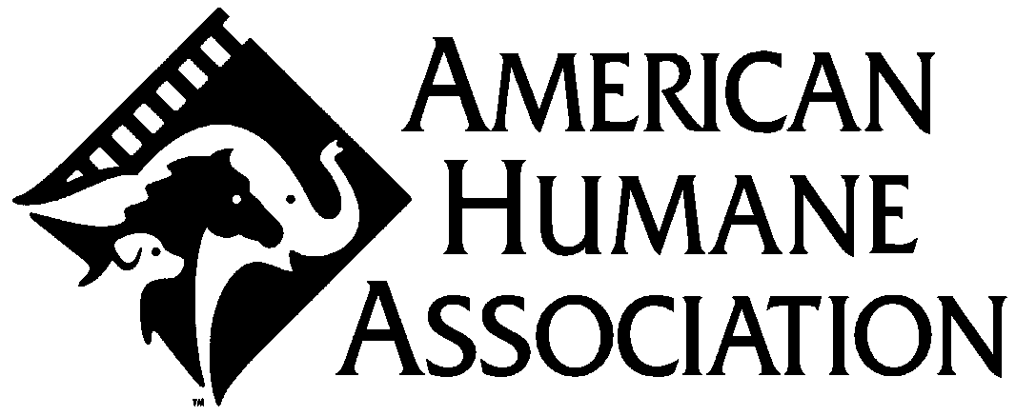 | American Humane Association monitored the animal action. No animal was harmed in the making of this film. (AHA 00342)

THE PRODUCERS WISH TO THANK:
Bico Jewelry Australia
Apollo Energy Systems for the use of the Silver Volt
Knoll Furniture
Plugg Apparel
The Gooderham & Worts Site / Cityscape Holdings, Inc.
Fredrikstad Fotball Klubb

Motion Imagery supplied by
Image Bank Film by Getty Images

"Malcolm in the Middle" still photograph courtesy of
Regency Television

SoloTrek is a trademark of Millennium Jet, Inc.,
and XFV is a registered trademark of Millennium Jet, Inc.,
and the SoloTrek XFV image is a copyright of Millennium Jet, Inc.

"Sci-Spy," "Codename: Knockout" and "Doom Patrol" comic books
used with permission from DC Comics

MAD Magazines and posters
used with permission from E.C. Publications, Inc.

Warcraft III®: Reign of Chaos™ footage courtesy of
Blizzard Entertainment®

"Hot In Herre"  Written by Charles L. Brown, Cornell Haynes, Jr., Pharrell L. Williams  Performed by Nelly  Courtesy of Universal Records  Under License from Universal Music Enterprises  "Fortune And Fame"  Written by Eric Tobias  Performed by The K.G.B.  Courtesy of DreamWorks Records  Under License from Universal Music Enterprises  "My Way"  Written and Performed by Butch Walker  Courtesy of Arista Records, Inc.  Under License from BMG Special Products, Inc.  "When I Get You Alone"  Written by Robin A. Thicke  Performed by Thicke  Courtesy of Interscope Records  Under license from Universal Music Enterprises  Contains a sample of "A Fifth of Beethoven"  Written and Performed by Walter Murphy  Courtesy of Thomas J. Valentino, Inc.  Under License from RFT Music Publishing Corp.  "Ain't No Fakin' The Funk"  Written by Eric Tobias  Performed by The K.G.B.  Courtesy of DreamWorks Records  Under License from Universal Music Enterprises  "Seven Days In The Sun"  Written and Performed by Askil Holm  Courtesy of Universal Music Norway  Under License from Universal Music Enterprises | "Teaching Myself To Dream"  Written and Performed by Katy Rose  Courtesy of V2  Under License from V2 Records, Inc.  "Sucka MC's "  Written by Ali Theodore, Vincent Alfieri  Performed by Grand Skeem  Courtesy of Canvas One  Under License from Deetown Entertainment Inc.  "I'm A Player"  Written by Moses Kremer, Eric Tobias  Performed by The K.G.B.  Courtesy of DreamWorks Records  Under License from Universal Music Enterprises  "What's Real"  Written by Shelley Peiken, Guy Roche  Performed by Janyelle Crawford  Courtesy of Ro Entertainment  "Get Free"  Written by Craig Nicholls  Performed by The Vines  Courtesy of Capitol Records  Under License from EMI Film & TV Music  "Life Is Good"  Produced and Remixed by Philip Steir  Written by Lloyd Neal  Performed by Junk  Junk appears courtesy of Spirit Music Group



Main Title Design Aspect Ratio
Titles by Eric Fitzgerald
Michael Townshend
Hollywood Title

Optical Sound Negative by N.T. Audio
Negative Cutter Gary Burritt
Color Timer Denny McNeill
Dolby Sound Consultant Bryan Pennington

Filmed at
Lions Gate Studios
Vancouver, British Columbia

Lighting and Grip Equipment by
William F. White International Inc.

Remote Crane Supplied by
Telescopic Camera Crane Ltd.

Digital Sound Recording and Re-Recording by
Wilshire Stages, Los Angeles, CA

Dailies Film Lab Services by
Rainmaker

Digital Motion Picture Laboratory Services
Provided by LaserPacific
High Definition Color Correction Tim Vincent
High Definition Editorial Services Val Eislenben
Jay Steinberg
LaserPacific Media Corporation Account Managers Nancy Fuller
Travis Avitabile
Digital Motion Picture Services Terry Brown
Stacy Underhill

Digital Cinema Preview Projection provided by


Hi Def Mix Playback Decks provided by




 |  |  |  |  | 
No. 39151   | 

Visit the MGM Website at:

WWW.MGM.COM

The events, characters and firms depicted in this motion picture are
fictitious. Any similarity to actual persons, living or dead,
or to actual firms is purely coincidental.

©2003 METRO-GOLDWYN-MAYER PICTURES INC.
ALL RIGHTS RESERVED.

METRO-GOLDWYN-MAYER PICTURES INC. is the author and creator of this motion picture
for the purpose of copyright and other laws in all countries throughout the world.

This motion picture is protected under the laws of the United States
and other countries. Unauthorized duplication, distribution or
exhibition may result in civil liability and criminal prosecution.

From
DISTRIBUTED BY MGM DISTRIBUTION CO.

 | Running Time: 96 minutes

